Milltown Elementary School
Presents
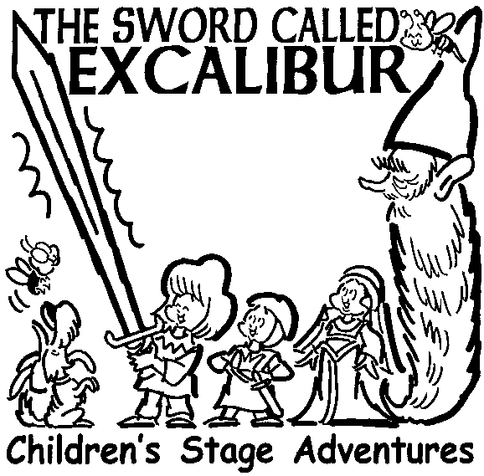
&
MES Family Birthday Party to Celebrate
Our 20th birthday in our building!

6 PM on Friday June 14, 2013

Admission is by donation-suggested minimum of $5/person to help us continue our Children’s Stage Adventures (about $3000 per year).

