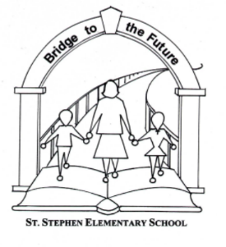St Stephen Elementary Home and School

Date: October 27 2021
Type of meeting: Home&School Monthly
Scribe: Heather Cloney

Attendees: Samantha Connick, Heather Cloney, Colleen Winchester, Naomi McConkey, Beth McCann, Catriona McLanaghan, Jeff Prosser, Jessica Bellis

Agenda Items:
Financial Account Update
- Deposit of $30 made from H&S fees
- Sam made a motion to move $5000 towards our playground upgrade goal
- Naomi second the motion

Outdoor Classroom
- Ground work has been started
- Concrete to start next, and will be done by maintence crew at the school
- We have some samples of the plaques for the structure

Donation Number update
- David Ames is donating his time to help us with this. He has been extremely busy, Naomi will follow up with him
Playground update
- Set a goal of $75,000 over the next couple of years
- We will be trying to promote and build excitement around the goals for purchasing new equipment
- Jessica will be talking to Rob Munn to see about meeting and going over some of the playground equipment
- Jessica & Catriona to try to create a video with the kids about the playground
Fundraising Ideas
- We will be doing our Christmas Auction again this year! It was a huge success last year.
-We have 90 donations
-32 items have been picked up
-We will use the same Facebook page as last year
- Peeler cards with various discounts to local restaurants
- School clothing

Action Items for Next Meeting
- Follow up about Auction

Next Meeting will be Nov 24th @ 730

