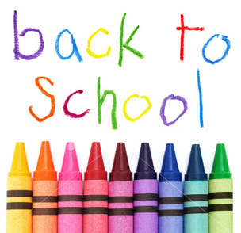

GRAND BAY PRIMARY

SCHOOL SUPPLIES: SEPTEMBER 2022
Grand Bay Primary Teachers will be purchasing student’s school supplies for the 2022-23 school year.
If you wish to go shopping for supplies with your child we would suggest getting a pencil box for home and filling it with pencils, erasers, crayons, glue and scissors that can be left at home and used to complete homework.

Items that should be sent in from home are:
1 pair of non-marking sneakers (labeled please)
An extra change of clothes (in a labeled bag)

We are requesting that parents pay $55 at the start of the school year to cover the cost of supplies that will be purchased by teachers. Please pay through SchoolCashOnline
This fee will ensure that your child will have the necessary supplies for the school year.

