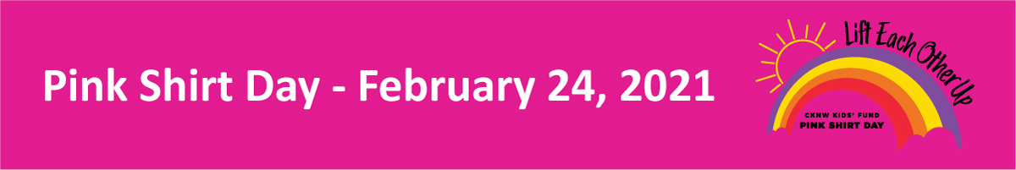
Now a movement celebrated across the globe, Pink Shirt Day has humble beginnings. Inspired by an act of kindness in small-town Nova Scotia, CKNW Kids' Fund, working with partners Boys & Girls Clubs and 980 CKNW, was inspired to raise funds to support anti-bullying programs. Here is a snippet of an article detailing the original incident: “David Shepherd, Travis Price and their teenage friends organized a high-school protest to wear pink in sympathy with a Grade 9 boy who was being bullied [for wearing a pink shirt]…[They] took a stand against bullying when they protested against the harassment of a new Grade 9 student by distributing pink T-shirts to all the boys in their school. ‘I learned that two people can come up with an idea, run with it, and it can do wonders,’ says Mr. Price, 17, who organized the pink protest. ‘Finally, someone stood up for a weaker kid.’ So Mr. Shepherd and some other headed off to a discount store and bought 50 pink tank tops. They sent out message to schoolmates that night, and the next morning they hauled the shirts to school in a plastic bag. As they stood in the foyer handing out the shirts, the bullied boy walked in. His face spoke volumes. ‘It looked like a huge weight was lifted off his shoulders,’ Mr. Price recalled. The bullies were never heard from again.” — GLOBE & MAIL
After David and Travis’ act of kindness in 2007, CKNW was inspired to help other youth affected by bullying, with many staff members wearing pink shirts and collecting funds to support Boys and Girls Clubs. Since then, the idea has only grown each year, with worldwide support and participation. Countries across the globe are now organizing anti-bullying fundraisers of their own, including Japan, New Zealand, China, Panama, and numerous others. In fact, last year alone, people in almost 180 countries shared their support of Pink Shirt Day through social media posts and donations.
On February 24, 2021, we encourage everyone to practice kindness and wear pink to symbolize that you do not tolerate bullying.
Each year our local Boys & Girls Club, located in our school and community, sell Pink shirts to raise awareness. $2 from the sale of each shirt sold by our school goes back to the school! Please see the order form. You may order online https://stores.inksoft.com/st-john-the-baptist/shop/home or submit order form and money to the school by Jan. 29th (a school order will go in).
------------------------------------------------------------------------------------------------------------------------------------------
Order Form to Be Submitted by Jan. 29th
$10 T-shirt sizes youth: XS(6-7); S(8-9); M(10-12); L(14-16); XL(18-20)
$12 T-shirt Adult sizes: S, M, L, XL, 2XL, 3XL, 4XL, 5XL
Adult Mask $8 and Child Mask $8
Name of Student: ___________________________
Teacher: ________________________
T-shirt size: ___________________
Mask size: __________________
Total money sent in: ________________

