
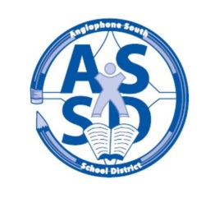
HAMPTON HIGH SCHOOL

ANGLOPHONE SOUTH SCHOOL DISTRICT
2015-16 SCHOOL CALENDAR

2015
September 8 Grade 9 Students Only
9 All students grades 9 – 12

October 8-9 Professional Learning Days for Staff – No Classes
12 Thanksgiving Day – No Classes

November 11 Remembrance Day – No Classes
26 Parent Teachers Interviews – 4:30 to 7:30 pm
27 No classes- Parent Teacher Interviews – 8:30 to 11:30 am

December 18 Last Day of First Term – full day

2016
January 4 Professional Learning Day for Staff – No Classes
5 First Day for Students
25-29 High School Exam Week (Grades 9-12)

February 1-2 Turnaround Days (Grades 9-12 Only – No Classes)
3 Start of Second Semester

March 7-11 March Break – No Classes
25, 28 Good Friday & Easter Monday – No classes
31 Parent Teacher Interviews- 4:30 to 7:30 pm

April 1 No Classes- Parent Teacher Interviews 8:30 to 11:30am

May 2 AP Exam – Psychology 12pm
4 AP Exam- English Literature & Composition 8am
5 AP Exam- Calculus AB
6 Provincial Council Day – No Classes
11 AP Exam- English Language & Composition 8am
20 Hampton Education Centre only - AEFNB & NBTA Meeting - No Classes
23 Victoria Day – No Classes

June 13-17 High School Exam Week (Grades 9-12)
24 Last Day for Students
27-28 Administration Days for Staff

NOTE: Two Professional Learning Days to be determined.

