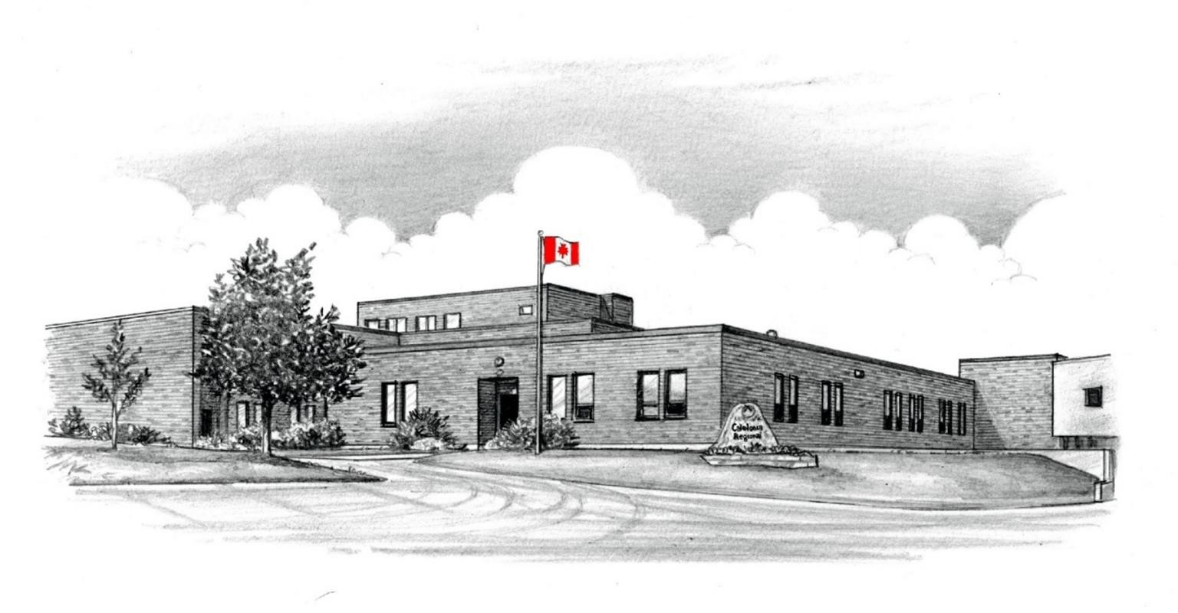

Caledonia
Regional High School

Supporting Learning at a Distance Plan

Grade Level Configuration

6

-

12

Acting Principal

Emily Ostler Colpitts

Acting Vice Principal

Erin Leger

Guidance

Heather Lean

When working together to support learning at a distance …
- Teachers will create an environment that is conducive to learning to help students develop their skills and realize their life and career plans. Activities will be meaningful and engaging and consider the student’s needs, interests, and aspirations.
- Teachers will guide students as they work independently and remain committed to learning (individual and group coaching and follow-up) and ensure that they maintain a real sense of belonging to their class and to their school.
- Teachers will communicate often with the students and / or parents. They will provide regular updates on progress in the learning plan to students and parents.

Table of Contents
I. Defining learning at a distance
a. Blended Learning in High School
II. Daily virtual guidelines for students
III. Social and Emotional Learning (SEL)
IV. Practical Application
a. Middle school instruction times
b. High school instruction times
V. Office hours

SECTION I Defining Learning at a Distance

High school students are expected to follow their course schedule, log into their subject TEAMS sites, and verify their student email each home learning day. There is a provincial expectation that subject teachers dedicate a minimum of 10 minutes per class to a live virtual meeting with students learning from home.

➢ When do students learn at a distance? | - Students in Grades 6 – 12 who are ordered to self-isolate or to remain at home by Public Health.  - Students in Grades 6 – 12 in the event of a school closure.  *Determined by Public Health  Or  *Predicted temperature, including humidex, of 36 degrees or more. (will be called similar to a snow day, before 6am)

In the event of a school closure, what can be expected in terms of guided instruction when learning at a distance? | Details
➢ For students in grades 6 – 12 | A balance of:  - teacher directed instruction.  - small group centered learning.  - student centered learning including discovery activities, personal creative projects, practical life learning, independent reading, interest projects, experiential learning, and physical activity.  - Student attendance will be taken.
➢ For students in Grades 6 – 8 | - Learning will be guided by teachers in a virtual environment.  - Support will be provided by teachers to use virtual spaces for learning, collaboration, and teamwork.  - Established course schedule will be maintained unless

 | otherwise communicated by teachers to students.
➢ For students in Grades 9 – 12 | - Teachers transition to an online learning model for all subject areas.  - Established course schedule is maintained.

How can students prepare to learn at a distance?

➢ For students in grades 6 – 12 | - Download Free Microsoft Office  365 for Schools and Students  - Ensure you use your school username and password. All teachers have access to this information if you run into difficulty.  - Check your student email daily.  - Activate your TEAMS sites.  - At designated virtual learning times throughout the instructional day, some teachers will invite students to TEAMS calls coinciding with the subject.

- The invitation will appear in the student outlook email box.
- Some teachers may not send an invitation to join, but it is expected the teacher and student will be present at the designated time.
- Videos of teacher pre-recorded sessions may appear on your TEAMs site.

Section II

Daily Virtual Guidelines
In the event of a school closure:

Teachers will ensure a balance of both synchronous (real time) and asynchronous instruction to limit student screen time.

Teachers may record the “live” (synchronous) instructional aspect (i.e., Not student interactions to maintain privacy) of the lesson for students to access with support when during office hours or another agreed upon convenient time.

Virtual learning should provide a balance of teacher-directed, small group centered, and individual support.

What is the recommended screen time for a learner engaged in a distance learning plan?
➢ Grade 6 & 7 | ➢ maximum 120 minutes active screen time / day
➢ Grade 8 | ➢ maximum 150 minutes active screen time / day
➢ Grades 6, 7 & 8 | In addition, students are  - Assigned 20 minutes / day of independent reading.  - Assigned 30 – 60 minutes / day of physical activity.

 | ➢ Assigned 15 minutes of independent home learning to follow up to each online session
➢ Grades 9, 10, 11 & 12 | - 3 hours / day (approximately 40 minutes /course).  - In-class time for instruction of learning expectations that require the most teacher support and for formative assessment of skills that are best assessed in person.  - Out of class time for learning outcomes that can be completed independently or in small online groups for practice of developing skills, for preparing for in class time for following up on in class work.

Section III

Social Emotional Learning (SEL)

Research confirms and teachers, parents, and principals agree: Social and emotional competencies can be taught, modeled, and practiced and lead to positive student outcomes that are important for success in school and in life.

Benefits of Social Emotional Learning
- Improvement in students’ social and emotional skills, attitudes, relationships, academic performance, and perceptions of classroom and school climate.
- Long-term improvements in students’ skills, attitudes, prosocial behaviour, and academic performance.
- Decline in students’ anxiety, behaviour problems, and substance use.
- Wise financial investment according to cost-benefit research.

Visit: https://casel.org/what-is-sel/

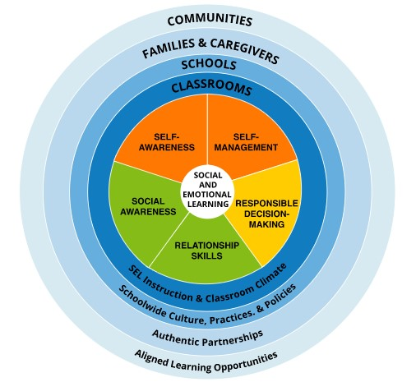

Section IV

Practical Application of Learning at a distance

In the event of a school closure, the following scheduled distance learning instructional times will apply. Teachers will reach out to students at designated times below.

Distance Learning Middle School Schedules

- Grade 6/7 English
Scheduled  Distance Learning  Instructional  Times | Homeroom teacher:  Ms. Flynn
 | Monday | Tuesday | Wednesday | Thursday | Friday
9am | English  Language Arts  – Ms. Flynn | English  Language Arts  – Ms. Flynn | English  Language Arts  – Ms. Flynn | English  Language Arts  – Ms. Flynn | English  Language Arts  – Ms. Flynn
10 am | Math  Mr. Kelly | Math  Mr. Kelly | Math  Mr. Kelly | Math  Mr. Kelly | Math  Mr. Kelly
11 am | Art  Ms. Strohmayr | Health/ PDCP  Ms. Milton | BBT  Mr. Kelly | Phys. Ed  Mrs. Wright | Music  Ms. Masson
1 pm | S1- Social Studies- Ms. Milton  S2- Science- Ms. Milton | S1- Social Studies- Ms. Milton  S2- Science- Ms. Milton | S1- Social Studies- Ms. Milton  S2- Science- Ms. Milton | S1- Social Studies- Ms. Milton  S2- Science- Ms. Milton | S1- Social Studies- Ms. Milton  S2- Science- Ms. Milton
2 pm  S2 – February  – June 2021 | S1 – PIF- Ms. Strohmayr  S2- PIF- Ms. Masson | Phys. Ed  Mrs. Wright | S1 – PIF- Ms. Strohmayr  S2- PIF- Ms. Masson | S1 – PIF- Ms. Strohmayr  S2- PIF- Ms. Masson | S1 – PIF- Ms. Strohmayr  S2- PIF- Ms. Masson

B. Grade 6 French Immersion
Scheduled  Distance Learning  Instructional  Times | Homeroom Teacher:  Mme Pellerin
 | Monday | Tuesday | Wednesday | Thursday | Friday
9 am | FILA-  Mme. Pellerin | FILA-  Mme. Pellerin | FILA-  Mme. Pellerin | FILA-  Mme. Pellerin | FILA-  Mme. Pellerin
10 am  S2 – February  – June 2021 | S1- Science Humaine- Mme. Pellerin  S2- Science- Mme. Pellerin | S1- Science Humaine- Mme. Pellerin  S2- Science- Mme. Pellerin | S1- Science Humaine- Mme. Pellerin  S2- Science- Mme. Pellerin | S1- Science Humaine- Mme. Pellerin  S2- Science- Mme. Pellerin | S1- Science Humaine- Mme. Pellerin  S2- Science- Mme. Pellerin
11 am | Health and PDCP- Ms. Milton | BBT-  Mr. Kelly | Phys. Ed  Mrs. Wright | Music-  Ms. Masson | Art-  Ms. Strohmayr
1 pm | Math-  Mr. Wilkinson | Math-  Mr. Wilkinson | Math-  Mr. Wilkinson | Math-  Mr. Wilkinson | Math-  Mr. Wilkinson
2 pm | English Language Arts-  Ms. Flynn | English Language Arts-  Ms. Flynn | English Language Arts-  Ms. Flynn | English Language Arts-  Ms. Flynn | English Language Arts-  Ms. Flynn

- Grade 7/8 English
Scheduled  Distance Learning  Instructional  Times | Homeroom Teacher:  Mr. Steeves
 | Monday | Tuesday | Wednesday | Thursday | Friday
9 am | Math – Mr.  Steeves | Math – Mr. Steeves | Math –Mr.  Steeves | Math – Mr.  Steeves | Math – Mr.  Steeves
10 am | English  Language Arts  – Mr. Patterson | English  Language Arts  – Mr. Patterson | English  Language Arts  – Mr. Patterson | English  Language Arts  – Mr. Patterson | English  Language Arts  – Mr. Patterson
11 am | Music- Ms. Masson | Art- Ms. Strohmayr | Health and PDCP- Ms. Milton | BBT-  Mr. Kelly | Phys. Ed-  Mrs. Wright
1 pm | French Mme  Strohmayr | French – Mme  Strohmayr | French – Mme  Strohmayr | French – Mme  Strohmayr | French – Mme  Strohmayr
2 pm | S1 Social  Studies – 7 Ms. Milton  8- Ms. Masson | S1 Social  Studies – 7 Ms. Milton  8- Ms. Masson | Phys. Ed-  Mrs. Wright | S1 Social  Studies – 7 Ms. Milton  8- Ms. Masson | S1 Social  Studies – 7 Ms. Milton  8- Ms. Masson

- Grade 7 French Immersion
Scheduled  Distance Learning  Instructional  Times | Homeroom Teacher:  Mr. Wilkinson
 | Monday | Tuesday | Wednesday | Thursday | Friday
9 am | Math-  Mr. Wilkinson | Math-  Mr. Wilkinson | Math-  Mr. Wilkinson | Math-  Mr. Wilkinson | Math-  Mr. Wilkinson
10 am | English  Language Arts  – Ms. Milton | English  Language Arts  – Ms. Milton | English  Language Arts  – Ms. Milton | English  Language Arts  – Ms. Milton | English  Language Arts  – Ms. Milton
11 am | BBT – Mr.  Kelly | Phys. Ed  Mrs. Wright | Music  Mme. Masson | Art – Mrs.  Strohmayr | PDCP – Health  - Mme Milton
1 pm | FILA-  Ms. Kadem | FILA-  Ms. Kadem | FILA-  Ms. Kadem | FILA-  Ms. Kadem | FILA-  Ms. Kadem
2 pm | S1- Science Humaine- Mme. Pellerin | S1- Science Humaine- Mme. Pellerin | S1- Science Humaine- Mme. Pellerin | Phys. Ed-  Mrs. Wright | S1- Science Humaine- Mme. Pellerin

- Grade 8 French Immersion
Scheduled  Distance Learning  Instructional  Times | Homeroom Teacher:  Mme Kadem
 | Monday | Tuesday | Wednesday | Thursday | Friday
9 am | French – Mme  Kadem | French – Mme  Kadem | French - Mme  Kadem | French – Mme  Kadem | French – Mme  Kadem
10 am | Math – Mme. Cremers | Math – Mme. Cremers | Math – Mme. Cremers | Math – Mme. Cremers | Math – Mme. Cremers
11 am | Phys. Ed  Mrs. Wright | Music  Ms. Masson | Art-  Ms. Strohmayr | Health and PDCP  Ms. Milton | BBT-  Mr. Kelly
1 pm | English Language Arts – Ms. Flynn | English Language Arts Ms. Flynn | English Language Arts – Ms. Flynn | English Language Arts Ms. Flynn | English Language Arts Ms. Flynn
2 pm | Phys. Ed  Mrs. Wright | S1 Social  Studies - Mme Kadem | S1 Social  Studies – Mme Kadem | S1 Social  Studies - Mme Kadem | S1 Social  Studies – Mme Kadem

High School Courses with teacher identified

Mrs. Babineau

Subject | Scheduled Distance Learning  Instructional Times
S 1
English LA 122(3) | 9 am
English LA 112 | 10 am
Journalism 12 | 11 am
Office Hours | 1 pm
Reading Tutor 12 | 2 pm

Mrs. Wright

Subject | Scheduled Distance Learning  Instructional Times
S 1
Office Hours | 9 am
Wellness 110 | 10 am
MS Phys. Ed. | 11 am
9/10 Phys. Ed. | 1 pm
MS Phys. Ed. | 2 pm

Mme Cremers

Subject | Scheduled Distance Learning  Instructional Times
S 1
Office Hours | 9 am
8 FI Math | 10 am
10 FI Science | 11 am
FI Enviro. Science | 1 pm
Biology 11 | 2 pm

Mrs. Dixon-Lipton

Subject | Scheduled Distance Learning  Instructional Times
S 1
9 English LA | 9 am
Office Hours | 10 am
10 Social Studies | 11 am
Child Studies | 1 pm
10 English LA | 2 pm

Mrs. Godbout

Subject | Scheduled Distance Learning  Instructional Times
S 1
Foundations 11 | 9 am
Pre Calc A 12 | 10 am
Office Hours | 11 am
Chemistry 11 | 1 pm
Pre-Calc B 12 | 2 pm

Mme Kadem

Subject | Scheduled Distance Learning  Instructional Times
S 1
8 FILA | 9 am
9/10 FILA | 10 am
Office Hours | 11 am
7 FILA | 1 pm
8FI Science Hum. | 2 pm

Mr. Kelly

Subject | Scheduled Distance Learning  Instructional Times
S 1
10 Science | 9 am
6/7 Math | 10 am
MS BBT | 11 am
9/10 BBT | 1 pm
Office Hours | 2 pm

Ms. Lean : Appointments can be scheduled by students, parents, and teachers. To book an appointment, visit the home page of our Caledonia website and on the Guidance TEAMS page.

Subject | Scheduled Distance Learning  Instructional Times
S 1
Office Hours | 9 am
Scheduled  Appointments | 10 am
Scheduled  Appointments | 11 am
Office Hours | 1 pm
Scheduled  Appointments | 2 pm
Mrs. Macintyre

Subject | Scheduled Distance Learning  Instructional Times
S 1
EA collaboration | 9 am
PLP review and maintenance | 10 am
Student / Family check-ins | 11 am
Student programming | 1 pm
Office Hours | 2 pm

Ms. Masson

Subject | Scheduled Distance Learning  Instructional Times
S 1
Music 110 | 9 am
Office Hours | 10 am
MS Music | 11 am
9/10 Music | 1 pm
8 Social Studies | 2 pm

Mr. Wilkinson

Subject | Scheduled Distance Learning  Instructional Times
S 1
7 FI Math | 9 am
10 FI GMF | 10 am
Office Hours | 11 am
6 FI Math | 1 pm
9 FI Math | 2 pm

Mr. Patterson

Subject | Scheduled Distance Learning  Instructional Times
S 1
9 English LA | 9 am
7/8 English LA | 10 am
9 Social Studies | 11 am
Prep | 1 pm
10 English LA | 2 pm

Mme. Pellerin

Subject | Scheduled Distance Learning  Instructional Times
S 1
6 FILA | 9 am
6 FI Science Hum. | 10 am
9 FI PDCP | 11 am
Office Hours | 1 pm
7 FI Science Hum. | 2 pm

Mrs. Robertson (Dutcher)

Subject | Scheduled Distance Learning  Instructional Times
S 1
Office Hours | 9 am
Essential Skills | 10 am
Housing | 11 am
9/10 Art | 1 pm
Fine Arts | 2 pm

Mr. Robertson

Subject | Scheduled Distance Learning  Instructional Times
S 1
Financial &  Workplace Math 11 | 9 am
Office Hours | 10 am
Metals 11 | 11 am
Site Layout &  Foundation 11 | 1 pm
Framing &  Sheathing 11 | 2 pm

M Roy

Subject | Scheduled Distance Learning  Instructional Times
S 1
6 FI Social Studies | 9 am
Office Hours | 10 am
FI Family Dynamics  12 | 11 am
Indigenous Studies | 1 pm
Outdoor Pursuits  11 | 2 pm

Mr Steeves

Subject | Scheduled Distance Learning  Instructional Times
S 1
7/8 Math | 9 am
10 GMF | 10 am
Office Hours | 11 am
Physics 11 | 1 pm
9 Math | 2 pm

Ms. Strohmayr

Subject | Scheduled Distance Learning  Instructional Times
S 1
Cul. Tech 11 | 9 am
Office Hours | 10 am
MS Art | 11 am
7/8 PIF | 1 pm
6/7 PIF | 2 pm

Section VI
Office Hours

During Designated Office Hours, staff can prioritize the following:
- Send and reply to emails.
- Make phone connections with home.
- Follow-up with students who have not connected on the Microsoft TEAMS platform.
- Lesson planning
- Evaluation of evidence
- In addition to the office hours designated below, all staff have daily office hours from 8:45-9 am and 3 – 3:15.
- S1= Semester 1 (September 2021 – end of January 2022)

Staff | Monday | Tuesday | Wednesday | Thursday | Friday
Emily Ostler- Colpitts  Acting Principal | 8:30 – 4 pm | 8:30 – 4 pm | 8:30 – 4 pm | 8:30 – 4 pm | 8:30 – 4 pm
Erin Leger  Acting Vice  Principal | 8:00 – 10 am  2-3pm | 8:00 – 10 am  2-3pm | 8:00 – 10 am  2-3pm | 8:00 – 10 am  2-3pm | 8:00 – 10 am  2-3pm
Heather  Lean  Guidance | 9-10 am  1-2 pm | 9-10 am  1-2 pm | 9-10 am  1-2 pm | 9-10 am  1-2 pm | 9-10 am  1-2 pm
Claudia Babineau | 1 – 2 pm | 1 – 2 pm | 1 – 2 pm | 1 – 2 pm | 1 – 2 pm
Madison Wright | 10-11 am | 10-11 am | 10-11 am | 10-11 am | 10-11 am
Caroline  Cremers | 9-10 am | 9-10 am | 9-10 am | 9-10 am | 9-10 am
Mrs. Dixon-  Lipton | 10-11 am | 10-11 am | 10-11 am | 10-11 am | 10-11am
Ms. Flynn | 11 -noon | 11-noon | 11-noon | 11-noon | 11-noon
Mrs. Godbout | 11-noon | 11-noon | 11-noon | 11-noon | 11-noon
Mme Kadem | 11-noon | 11-noon | 11-noon | 11-noon | 11-noon
Mr. Kelly | 2-3pm | 2-3pm | 2-3pm | 2-3pm | 2-3pm

 | Monday | Tuesday | Wednesday | Thursday | Friday
Ms. Masson | 10-11 am | 10-11 am | 10-11 am | 10-11 am | 10-11 am
Ms. Milton | 9-10 am | 9-10 am | 9-10 am | 9-10 am | 9-10 am
Mr. Wilkinson | 11- noon | 11- noon | 11- noon | 11- noon | 11- noon
Mr. Patterson | 1-2 pm | 1-2 pm | 1-2 pm | 1-2 pm | 1-2 pm
Mme  Pellerin | 1-2 pm | 1-2 pm | 1-2 pm | 1-2 pm | 1-2 pm
Mrs. Robertson | 9-10 am | 9-10 am | 9-10 am | 9-10 am | 9-10 am
Mr. Robertson | 10-11 am | 10-11 am | 10-11 am | 10-11 am | 10-11 am
M Roy | 10-11 am | 10-11 am | 10-11 am | 10-11 am | 10-11 am
Mr. Steeves | 11- noon | 11- noon | 11- noon | 11- noon | 11- noon
Mrs. Strohmayr | 10-11 am | 10-11 am | 10-11 am | 10-11 am | 10-11 am

